Slot model with travel distance

Range Sets for time and slots:
$Teams: T∈\{1,2,....,n\}$
$Time slots: S∈\{1,2,....,S\}$

Decision Variables:
- $x_{ijs}∈\{0,1\}$
Meaning: If team i plays away game versus team j at slot s, then $x_{ijs}$ =1.
- ${loc}_{isk}∈\{0,1\}$
Meaning: If team i stays at team k’s home stadium at slot s, then ${loc}_{isk}$=1. In shorts, team i stays at k in slot s.
- ${travel}_{isk_{1}k_{2}}∈\{0,1\}$
Meaning: If team i stays in stadium $k_{1}$ at slot s, and stadium k2 at slot s+1, then ${travel}_{isk_{1}k_{2}}$=1.

Objective Functions:

$min\sum_{i∈T}{}\sum_{s=1}^{S}{}\sum_{k_{1}∈T}{}\sum_{k_{2}∈T}{}{travel}_{isk_{1}k_{2}}⋅d_{k_{1}k_{2}}$
Our goal is to minimize total travel distances.

Constraints:
Game Constraints:

- No self games:
$x_{iis}=0, ∀i∈T, ∀s∈S$
- At least 6 series played for each team (Initially 8 series per month):
$\sum_{j∈T}{}\sum_{s∈S}{}x_{ijs}+\sum_{j∈T}{}\sum_{s∈S}{}x_{jis} ≥6, ∀i∈T$
- One team per slot in the series:
$\sum_{j∈T, j≠i}{}x_{ijs}+\sum_{j∈T, j≠i}{}x_{jis} ≤1, ∀i∈T, ∀s∈S$
- Number of away series >= required number (set 2 here):
$\sum_{j∈T}{}\sum_{s∈S}{}x_{ijs}≥2, ∀i∈T$
- Number of home series >= required number:
$\sum_{j∈T}{}\sum_{s∈S}{}x_{jis}≥2, ∀i∈T$
- No back to back series (in the same stadium?)
- $x_{ijs}+x_{ij,s+1} ≤1, ∀i,j∈T, i≠j, ∀s=1,2,...,S-1$
Location Constraints:
- Each team should stay in one stadium at each slot (even if they don’t play at that slot):
$\sum_{k∈T}{}{loc}_{isk}=1, ∀i∈T,∀s∈S$
- If team i is the home team, they should stay at their home stadium at slot s:
${loc}_{isi}≥\sum_{j∈T, j≠i}{}x_{jis}=1, ∀i∈T,∀s∈S$
- If team i is playing an away game versus team j, they should stay at team j’s stadium at slot s:
${loc}_{isj}≥x_{ijs}, ∀i∈T,∀j∈T,j≠i,∀s∈S$
- Travel–location linking constraints:
${travel}_{isk_{1}k_{2}}≤{loc}_{isk_{1}}$ and
${travel}_{isk_{1}k_{2}}≤{loc}_{i,s+1,k_{2}}$ and
${travel}_{isk_{1}k_{2}}≥{loc}_{isk_{1}}+{loc}_{i,s+1,k_{2}}-1$, $∀i∈T, ∀s=1,2,...,S-1,∀k_{1},k_{2}∈T$

Notes:
1. These constraints aim to describe the route for each team, and to ensure our objective function could be linear. If we chose to use only locations to calculate the distances, the objective function would be$Distance⋅{loc}_{i,s,k_{1}}⋅{loc}_{i,s+1,k_{2}}$, which is nonlinear.
2. The linking values we want are as below, here we just use three equations to get these results.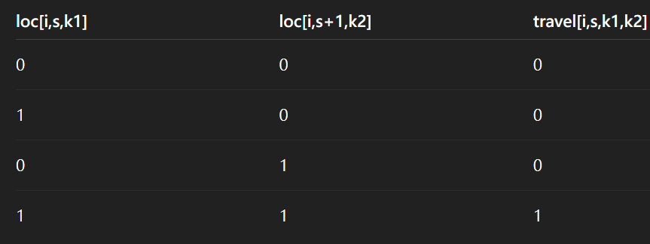
3. We could have written these 3 constraints as ${travel}_{isk_{1}k_{2}}={loc}_{isk1}⋅{loc}_{i,s+1,k_{2}}$, but this is nonlinear. In order to make them linear, we split this equation into 3 constraints. The way we did this is same as transforming
z = x AND y，x,y,z ∈ {0,1} to
z<=x, z<=y, x>=x+y-1, x,y,z ∈ {0,1}.

- d

Questions:
- If team i doesn’t play at slot s, where would they stay? Would they keep staying at the stadium where they were at?

Ans: We did not limit them to stay at the place. Instead, we let the objective function decide it. Under the normal condition, the model would automatically choose to stay put, but if there’s a choice that allow them to minimize the total distance, they would potentially choose to fly to an intermediate city, then fly to their destination.

- The model results:
With overall 3100 constraints and 1275 variables, we found the minimal total travel distance of 3873.94 miles.

Presolve removed 1965 rows and 215 columns
Presolved: 1135 rows, 1060 columns, 4060 nonzeros

This means the Gurobi solver helps us to simplify redundant variables and constraints while computing, at the end the model input includes 1135 constraints and 1060 variables.

